**CHAPTER 7**

**SYSTEM IMPLEMENTATION**

**7.1. INTRODUCTION**

Systems implementation is the process of:

* defining how the information system should be built (i.e., physical system design),
* ensuring that the information system is operational and used,
* ensuring that the information system meets quality standard (i.e., quality assurance).

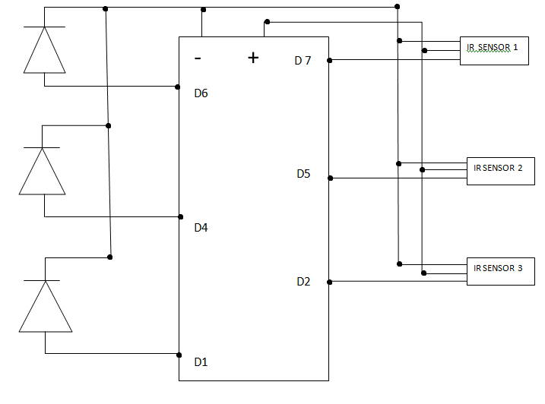

Figure 18: Circuit Diagram for Car Parking System

**7.2. USER INTERFACE**

The user interface (UI), in the industrial design field of human–computer interaction, is the space where interactions between humans and machines occur. The goal of this interaction is to allow effective operation and control of the machine from the human end, whilst the machine simultaneously feeds back information that aids the operators' decision-making process. Examples of this broad concept of user interfaces include the interactive aspects of computer operating systems, hand tools, heavy machinery operator controls, and process controls. The design considerations applicable when creating user interfaces are related to or involve such disciplines as ergonomics and psychology.

Generally, the goal of user interface design is to produce a user interface which makes it easy, efficient, and enjoyable (user-friendly) to operate a machine in the way which produces the desired result. This generally means that the operator needs to provide minimal input to achieve the desired output, and also that the machine minimizes undesired outputs to the human.

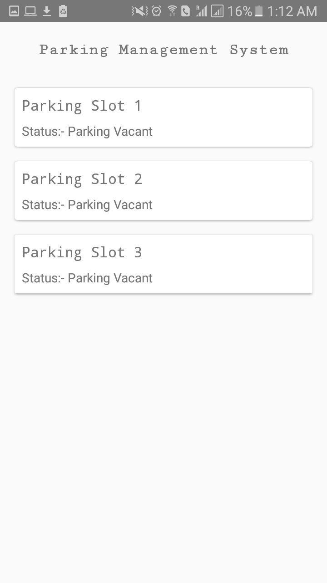Figure 19: User Interface

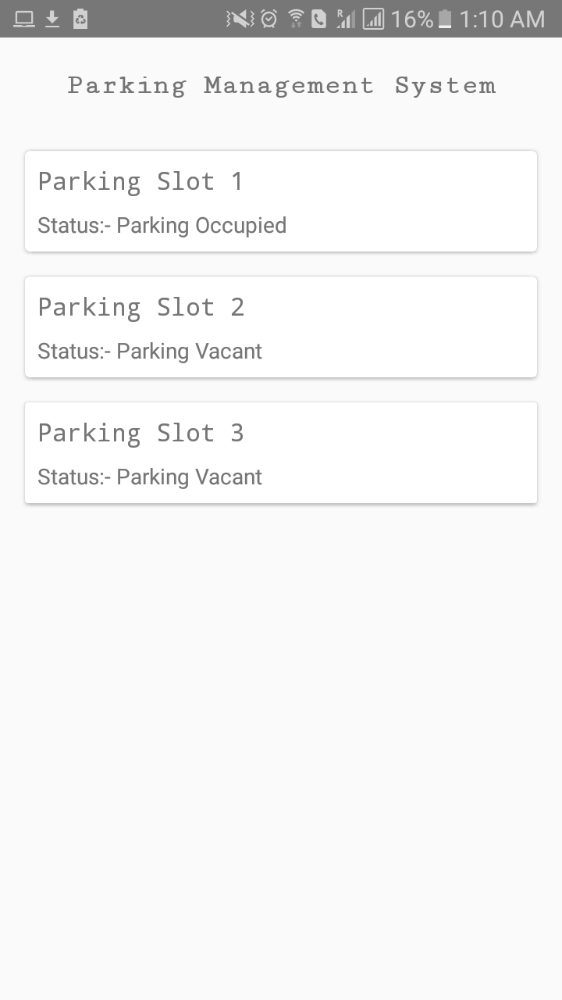

Figure 20: User Interface

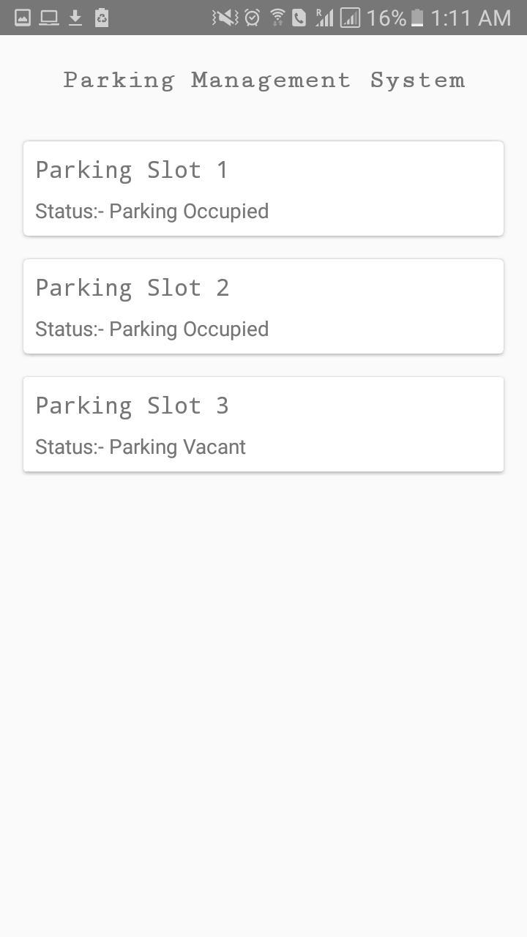

Figure 21: User Interface

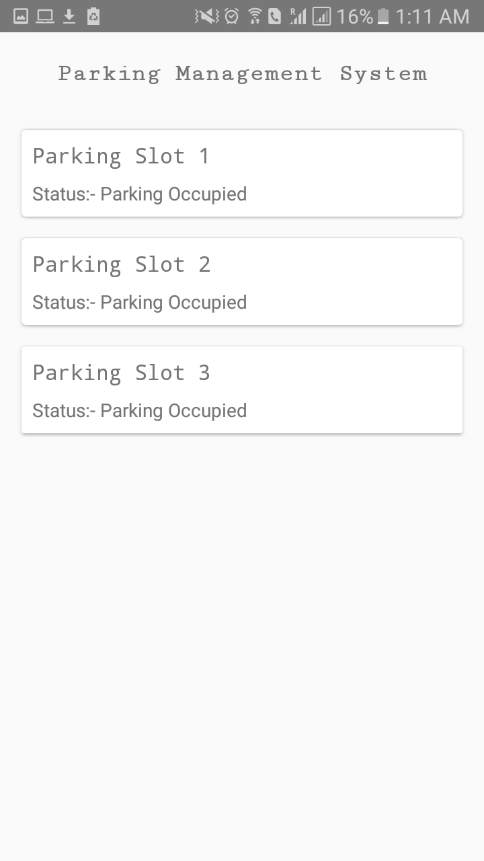

Figure 22: User Interface